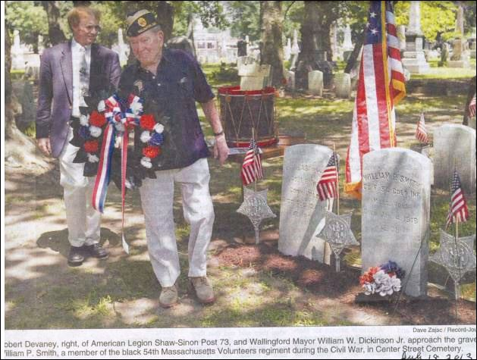

**Member of Historic Unit is Buried Locally**By Andrew Ragali Record-Journal July 19, 2013  
  
Thursday marked the 150th anniversary of the Civil War Battle of Fort Wagner, during which Union soldiers assaulted a Confederate stronghold built to protect Morris Island in South Carolina’s Charleston Harbor.  
  
Between July 11 and 18, 1863, the Union was twice unsuccessful in taking the fort, known to the Confederates as Battery Wagner. The second assault was led by the 54th Massachusetts Volunteers, the first black regiment to lead the charge against a major Confederate emplacement, said local historian Bob Beaumont. The battle was depicted in the 1989 film "Glory."  
  
During the battle, only 36 Confederate soldiers were killed, while the Union suffered 1,515 casualties: 246 dead, 880 wounded and 389 missing, Beaumont said. But even after sustaining three wounds, one Wallingford resident from the 54th Massachusetts managed to “return home to a hero’s welcome,” said Bob Devaney, who oversees the Center Street Cemetery. That was William P. Smith, who has an inconspicuous grave in the cemetery.  
  
Smith’s life and contributions to Wallingford were honored in a ceremony at the cemetery Thursday morning. Mayor William W. Dickinson Jr. and American Legion Shaw-Sinon Post 73 member Robert Devaney (Bob Devaney’s father) laid a wreath in front of Smith’s gravestone as local veterans and historians looked on.  
  
Post 73 made Smith an honorary member in 2008, Robert Devaney said. The ceremony was organized by Bob Devaney, who found out that Smith was buried in the cemetery in 2005 when Civil War re-enactors from the 54th Massachusetts Volunteers visited the cemetery to pay their respects.  
  
“Every monument in this cemetery tells a story,” Devaney said. “It’s just admirable. I would have never known the history of this man if it wasn’t for these people.”  
  
Smith was born in 1838 in Middlefield, Devaney said. He lived at a time when the Constitution considered him only three-fifths of a person. Smith made his way to Wallingford, where for years he made a living as a trapper along Community Lake. When the Civil War broke out in 1861, Devaney said, black men were not allowed to serve in the Union army. But in 1863, they were allowed to form armed ranks led by a white captain, he said. After surviving the assault on Fort Wagner, Smith went on to fight in Florida in 1864, Devaney said, after which he returned to Wallingford and was granted 26 acres of land near Community Lake, where he lived until he died at 78 in 1916. He had four children.  
  
“He was a volunteer in the first black regiment, and because of his bravery in that battle alongside his fellow soldiers, he brought glory to Wallingford, Connecticut, the United States, and indeed the world,” said Peter Gouveia, president of the Center Street Cemetery Association.  
  
Before the visit of the Civil War re-enactors, Devaney had been aware of Smith’s monument, but did not know he was black. What was astonishing to Dickinson about Smith is that he didn’t join the military in Wallingford. “He had to travel to Massachusetts to join the regiment,” Dickinson said. “He felt that strongly about it. His legacy should be revered by all of us.”  
  
Smith could not have joined a Connecticut regiment, as state law still prohibited black and American Indian enlistment. In 2008, Dickinson declared May 2 William P. Smith Day.  
  
Smith’s legacy went beyond his action in battle, Devaney said. He was the founding member of the Dred-Nots, a local fife and drum group. On display during Thursday’s ceremony was Smith’s drum, made in 1819. Along with the drum were photos of Smith with other members of the group. One photo shows Smith with his drum in front of Wallingford’s train station as part of the Wallingford National Band. Smith was the only black member of the band. He was also captain of the Jackson Blues black baseball team.  
  
Also involved in the Battle of Fort Wagner were Wallingford soldiers Henry Austin and Charles Hills. Both were white, and served in the 7th Connecticut Volunteers, Beaumont said. Dr. Benjamin Franklin Harrison, for whom Harrison Park in Wallingford was named, served as a surgeon during the battle, he said. Harrison owned a medical practice in town.  
  
Regarding the battle, Beaumont said, “The 54th more than proved its worth that day, showing that black soldiers could be tenacious, disciplined fighters, who would add to the strength of the Union Army.”