Oldest gravestones get some TLC
Leigh Tauss Record-Journal Meriden, CT) September 8, 2015

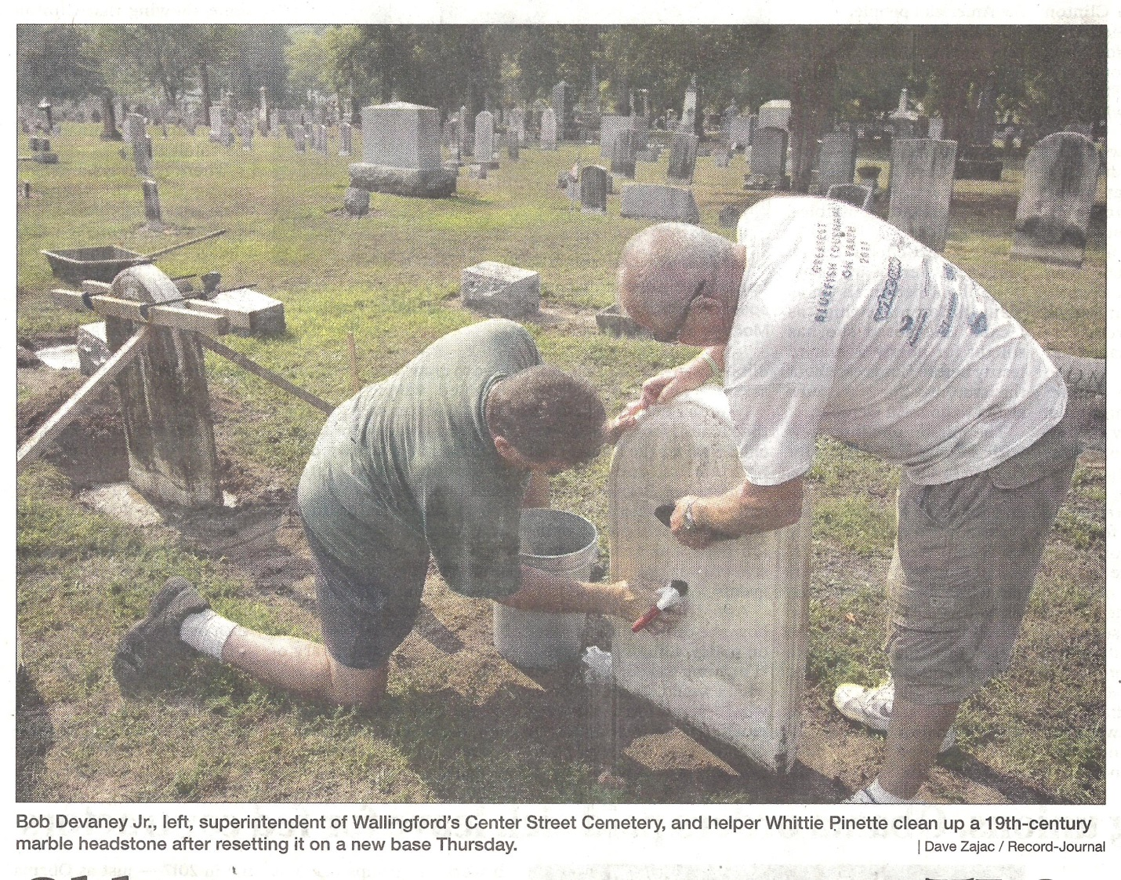
WALLINGFORD - Time has worn many of stones that mark the oldest graves in the Center Street Cemetery. Some have darkened so much they cannot be read, while others slump on crumbling foundations.

Cemetery superintendent Bob Devaney has been cleaning the marble stones and monuments and poured new foundations to straighten others in preparation for next month's Celebrate Wallingford festival.

The cemetery dates back to the 1670s and serves as the resting place for many prominent figures in the town's history. Weather has taken its toll on many of the gravestones over the centuries, keeping Devaney and fellow cemetery staffer Clarence Pinnette busy.
Stones that have fallen or are leaning need to be dug up so new foundations can be poured.

Epoxy is used to piece larger monuments back together. A special chemical solution is poured on the marble obelisks and then scrubbed in, transforming the gray and dirty stones that have darkened over time.

"You can't use a power washer," Devaney said. "It will ruin the monument."

Some repairs require a specialized approach. An 1888 zinc memorial, known as an "inky," had slumped over against the northern cemetery wall. The hollow memorial is made of metal. Devaney was able to dig it up and set it straight for the first time in decades.

Another monument from the 1800s had titled over on a loose stone foundation. Devaney used a backhoe to move the 700-pound monument, which was in pieces, so he could dig up the foundation and level it. Epoxy was used to join the pieces back together.

The cemetery also hires a company called Beyond the Gravestone to restore the brownstone monuments, which are more porous and susceptible to degradation from weather over time.

Association president, Peter Gouveia, said the association will pay the company $16,500 this year for repairs to brownstone monuments.

Gouveia said he is proud of the work Devaney has done restoring the graves and monuments and hopes it will attract more visitors.

"This is like an oasis in downtown Wallingford," Gouveia said. "We want people to come and enjoy it."

Artwork will be hung in the cemetery as part of this year's Celebrate Wallingford, which take place Oct. 3-4.

He says they are trying to repair and clean as many grave markers as possible before the annual festival.

"All cemetery memorials are considered art and it just enhances Celebrate Wallingford," Devaney said.

ltauss@record-journal.com 203-317-2231 Twitter: @LeighTaussRJ

