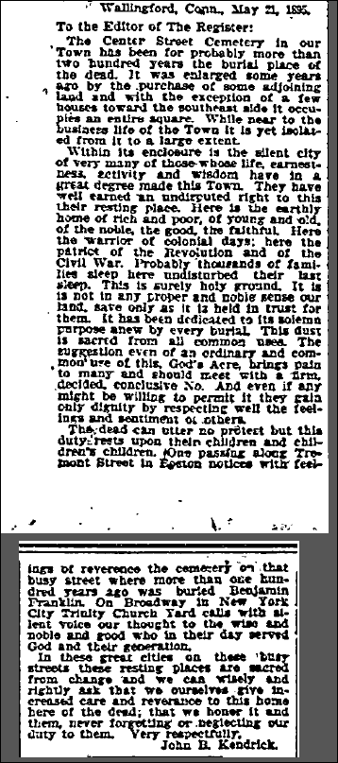
New Haven Register Pg. 6
May 22, 1895

Found in:
http://www.GenealogyBank.com

