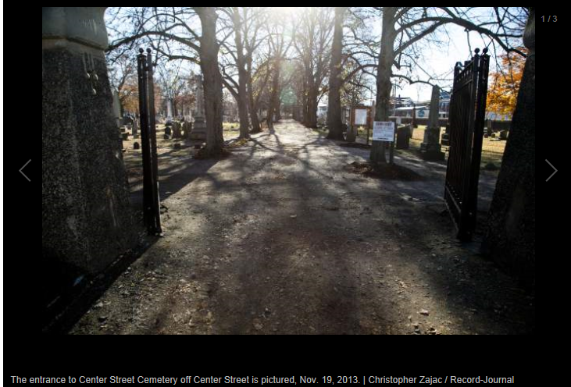

Funding approved for cemetery building /
Published: January 13, 2015 | Last Modified: January 13, 2015 10:43PM
By Leigh Tauss Record-Journal staff
WALLINGFORD — A new building with an office, meeting room and equipment storage space for the Center Street Cemetery is expected to be constructed after $275,000 in funding was recently approved by the State Bond Commission.
The new building for the historic cemetery will be built on Prince Street. The cemetery dates back to the 1670s and is the burial site of many influential figures in the town’s history.
Architect Steven Lazarus of Lazarus & Sargeant said the project calls for the demolition of the existing storage facility and the construction of a new 1,800-square-foot building on Prince Street designed to look like an old Victorian-style barn. Designs cost an estimated $30,000. The town purchased two houses on Prince Street to make way for the new building.
“Everyone is very focused on having an appropriate-looking building for that site that will complement the cemetery,” Lazarus said.
The majority of the new building will be used to store equipment for managing the cemetery, while the remainder will be a small office and meeting room.
Gouveia said he hopes to eventually convert the meeting room into a small museum and research center for the community.
He said the next step is for the architect to finalize design plans so the work can be put out to bid. The Town Council also has final approval of the work, which could begin in spring, Gouveia said.
The cemetery association was founded in 1913 and receives the majority of its annual funding from the town. It has 70 members.
“If anyone wants to know anything about the history of Wallingford, all they have to do is go to the Center Street Cemetery and look at those stones,” Gouveia said. “It was laid out when the town was pretty much founded.”
He said the oldest stone dates back to 1673.
State Rep. Mary Fritz, D-Wallingford, said she was glad the association would have sufficient space to house the equipment and records vital to the upkeep and preservation of the cemetery.
“I’m very happy for them,” Fritz said. “I think this gives them the opportunity to bring the cemetery into the 21st century.”
Gouveia said the association would have never received the funding if not for Fritz and state Rep. Mary Mushinsky, D-Wallingford.
“And of course we are grateful to the town of Wallingford for initiating this project,” Gouveia said.
ltauss@record-journal.com (203) 317-2231 Twitter: @LeighTaussRJ

