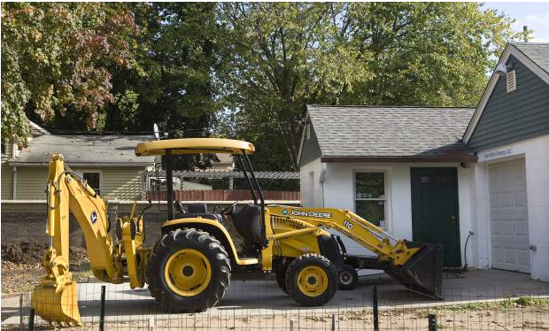

A backhoe used for digging graves parked in front of a maintenance garage at Center Cemetery in Wallingford, Thursday, October 17, 2013. | Dave Zajac / Record-Journal

**Wallingford cemetery association will seek bid waiver for garage/office project**

***Published: August 6, 2014* | *Last Modified: August 6, 2014 10:04PM***

By Andrew Ragali Record-Journal staff

WALLINGFORD — The Center Street Cemetery Association will seek a bid waiver from the Town Council to hire Steve Lazarus as the architect for a project that involves the construction of a new garage and office for the cemetery on Prince Street.

Lazarus, who works for Lazarus & Sargeant, is a member of the Center Street Cemetery Association. He has performed “a bulk of the design work” on the project so far at no charge, said Peter Gouveia, the association’s president.

The town owns the cemetery, but the association is responsible for upkeep. The town provides the association with about $70,000 annually. Last year, the town purchased two vacant homes adjacent to the cemetery, at 58 and 60 Prince St., for future use.

The town appropriated $268,000 for the purchase of both homes and demolition of 58 Prince St., with the idea that 60 Prince St. could be used as an office building and garage. But a structural study later revealed that 60 Prince St. could not be used as a garage, so both homes must be demolished.

Gouveia said the association is now looking to build a new office and garage on the town-owned parcel. The Town Council has yet to approve a project design or allocate funds. The association will seek design approval when the Town Council meets on Aug. 12, Gouveia said. The association will seek the bid waiver next Tuesday as well. But the association won’t seek funding from the town yet, he said.

State Reps. Mary Fritz and Mary Mushinsky were able to get the state legislature to appropriate $275,000 for the project this year. The bond commission, headed by the governor, must still vote to release the funds. Gouveia said he has been assured the money will be released, but remains cautious.

There is concern that if the town starts spending money on the project, “the state won’t give us any,” Gouveia said.

The town is “hoping for state funding on this,” said Mayor William W. Dickinson Jr. It’s unclear how the town would proceed with the project if the state money is not granted, he said.

While Lazarus would be the preferred architect, Gouveia said, “It’s no problem if the council decides to reject that request and go to public bid.”

But contracting with Lazarus could save the town money, he added.

Town Council Chairman Vincent Cervoni said the council has had an opportunity to look at preliminary plans and provide input to Lazarus.

“I didn’t have a strong feeling either way,” Cervoni said. “I’m not on the association, so I’d expect they would tell me how the location would best suit their needs.”

#### Originally found at [Wallingford cemetery association will seek bid waiver for garage/office project](http://www.myrecordjournal.com/wallingford/wallingfordnews/5219581-129/wallingford-cemetery-association-will-seek-bid-waiver-for-garageoffice-project.html)