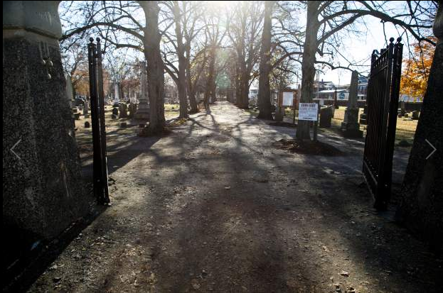

The entrance to Center Street Cemetery off Center Street is pictured, Nov. 19, 2013.  | Christopher Zajac / Record-Journal | Matthew Bailey, president of B.C. Bailey Funeral Home, sits in the main parlor for a picture on Friday, Nov. 22, 2013. Bailey donated money to fund the creation of a website for the Center Street Cemetery in town. | Christopher Zajac / Record-Journal

Financial help offered to provide online info on Center Street Cemetery
Published: November 25, 2013 | Last Modified: November 25, 2013 06:59PM
By Andrew Ragali Record-Journal Staff
WALLINGFORD — With the help of a local funeral home, information about the Center Street Cemetery will soon be accessible online.
Earlier this month, the Record-Journal reported that the Center Street Cemetery Association was hoping to establish a website by early next year. Peter Gouveia, the association’s president since June, said that shortly after the article ran he was contacted by Matthew Bailey, president of B.C. Bailey Funeral Home on South Elm Street. Bailey, a member of the cemetery association, offered to cover all costs of developing a website.
Bailey is the fourth generation of his family to operate the funeral home. He has become more involved with the cemetery association recently, serving on a committee that looked into cemetery’s purchase of two properties on Prince Street.
At this point, there is no cost estimate, because the site is under construction, Bailey said. Building a website was a goal in previous years, according to former president Jerry Farrell Jr. The association invested $4,000 about seven years ago to develop a website using aerial photographs so that the cemetery could be viewed through an online map. At the time, the plan posed a technical challenge, and wasn’t completed. The association has been paying $30 annually for ownership of the internet domain name centerstreetcemetery.org.
Gouveia said Chris Shortell, secretary of the cemetery association, is providing technical help.
“They have almost finished the project,” Gouveia said of Shortell and Bailey. “Chris (Shortell) said it’s a great thing; a beautiful web page he’s setting up.”
Gouveia said he appreciates Bailey’s financial help and support for the website project.
Bailey said the cemetery needs a better way to share historical information and offer other insights, such as tour and event schedules. The website might help people realize that the cemetery is still active as a burial site, he said.
When talking to families at the funeral home, people often mention that they have family members buried at the cemetery, so “when they find out it’s still active, sometimes they’re still a little surprised,” Bailey said.
A website is an important step for the association, he added, because “the cemetery itself is just such a big part of Wallingford’s history in terms of its founders and prominent people in the community.”
“It helps tell the community’s story,” Bailey said.
Gouveia and Bailey have also discussed creating a Facebook account. Bailey said he has already constructed much of the Facebook page, which has yet to be made public. When launched, Bailey said, the page can be found at Facebook.com/centerstreetcemetery.
The page will offer another means to disperse information about the cemetery, he said.
The nonprofit cemetery association receives about $70,000 a year from the town. The cemetery is town-owned but operated by the association.

Originally found at Financial help offered to provide online info on Center Street Cemetery

