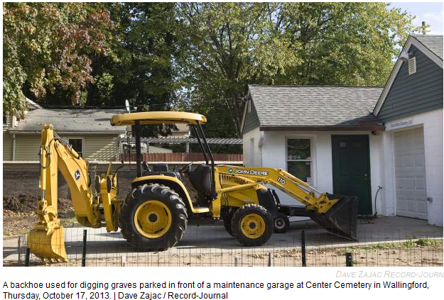

Wallingford cemetery group asks councilors for more money
Published: October 17, 2013 | Last Modified: December 2, 2013 04:23PM
By Andrew Ragali Record-Journal staff
WALLINGFORD — When the Town Council approved the purchase of two Prince Street homes in June, the plan was to demolish one and leave the other standing. Since both homes border the Center Street Cemetery, town officials thought the one left standing could be used as an office and storage garage by the Center Street Cemetery Association.
But a feasibility study after the purchase has changed plans, said Peter Gouveia, the cemetery association’s president. Both homes must be demolished because the house at 58 Prince St. cannot be used as a garage to store a backhoe used to dig graves.
“We need an industrial garage,” Gouveia said. The study showed 58 Prince St. cannot be used because of its underground basement, he said.
Gouveia delivered a letter to Mayor William W. Dickinson Jr. earlier this week asking that the Town Council consider spending another $30,000 to demolish the house.
In June, the council voted to approve the purchase of 58 Prince St. for $148,000, and the purchase of 60 Prince St. for $90,000. Dickinson said the purchase was important because it’s not often land next to the cemetery becomes available. The cemetery is owned by the town, but through an agreement made in 1911, the association is responsible for its upkeep. The town provides the association with about $70,000 annually.
The purchases were made because cemetery caretaker Bob Devaney’s office is small and located inside a maintenance garage. A backhoe purchased by the town for the cemetery last year is stored outside under a tarp. In June, the council approved the transfer of $120,000 to purchase 60 Prince St., undergo environmental assessments and demolish the unoccupied home. Councilors purchased the home in a 6 to 3 vote. Town Councilor Jason Zandri, a Democratic candidate for mayor, likened the purchase to a “lesser of two evils” because the home was vacant for years.
Dickinson said Wednesday that the association never indicated to the council that it would definitely be using 58 Prince St. as an office and garage. In June, Dickinson said while more estimates need to be put together, “the time to act with regard to real estate is now.”
Councilors said that they were surprised to learn they would be asked to approve more money for demolition.
“I need to find out what changed,” said Democrat Jason Zandri. “It was my understanding they’d use the house as an office area and a storage garage.”
“It took me by surprise,” said fellow Democrat John Sullivan. “I’m very concerned, because down the road the association may come looking for money to use in addition to current funds to rebuild this property.”
Sullivan suggested the cemetery association use available town office space so that just a small garage would need to be built. Or the existing garage can be modified.
“If we have extra offices, I’d much rather see that,” he said.
Town Councilor Nick Economopoulos, a Democrat, was the only council member to vote against the purchase of both homes.
“I’m not going to be in favor of spending additional monies to achieve what they thought they were going to achieve with the purchase,” he said.
When councilors were told by the Republican mayor at the last council meeting that 58 Prince St. would have to be demolished, Economopoulos said, “everyone was confused.”
“I’m never surprised any longer as a councilor as to what the real story is after the story has been told to me,” he added.
Town Council Chairman Bob Parisi, a Republican, said he was under the impression the association had already discussed and decided 58 Prince St. would be used as an office and garage.
“I was a little surprised,” Parisi said.
The cemetery association will hold it’s next meeting on Oct. 24 in room 315 of Town Hall. Meetings are open to the public.
Originally found at Group asks council for more

